Instructions Survey EDAP

Introduction

In this survey, you will test the extensions to Jira Cloud that have been developed during the Bachelors Thesis “EDAP- Ethical Deliberation in Agile Processes”. EDAP is a schema that is used to assists teams in the process of documenting the ethical and moral dimension of their development decisions clearly and concisely. It has been integrated into Jira.

Jira has been extended in two ways:

1. The EDAP schema, which is a document that developers can fill out, has been transformed into a Confluence page template.
2. An app has been added that provides a checklist. This checklist app can be filled out before using the EDAP template to provide knowledge and important pointers as to what should be considered during the EDAP process and development in general.

**Jira**

Jira can be used to manage and document issues (which can be tasks, user stories etc.) in a way that is suitable for agile processes. Jira provides documentation via Confluence pages. These pages can be created using templates, that provide structure that can be filled out.

Scenario

You are a member of a development team using Scrum. Your team is working on a work management and communication tool. Right now, you are in the Sprint Planning meeting. You and your colleagues have selected the following issue from the product backlog: “The productivity of employees is calculated with the data provided by the management functions of the system. The results are presented to the team manager” You and your team are not sure about the moral implications of this goal, so you start the EDAP process. (This example has been adapted from a Microsoft teams feature: <https://www.theguardian.com/technology/2020/nov/26/microsoft-productivity-score-feature-criticised-workplace-surveillance>)

**Sprint Planning meeting**

In the Sprint Planning Meeting a set of items from the backlog is selected to be worked on during the following sprint. The selected items are discussed, refined and broken down into more concrete tasks.

Instructions

**Step 1:**

Open <https://edap.atlassian.net/> and log in using the credentials:

Email: [edaptesting@gmail.com](mailto:edaptesting@gmail.com)

Password: edaptester

**Step 2:**



On the top bar, click “Apps”, then select “Checklist”, you will arrive at the checklist app.

Check “Data related checkpoints”, then check all the points that apply to the feature. Then click submit.

You will be presented with text that informs you about important information that fit the checkpoints you selected. Read the text.

**Step 3:**

Go to “Projects” on the top bar, then select “Bachelorarbeit”.

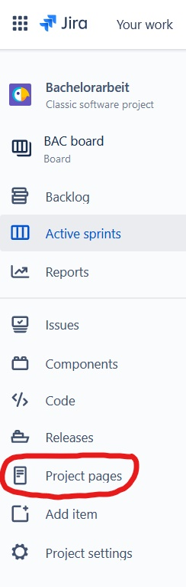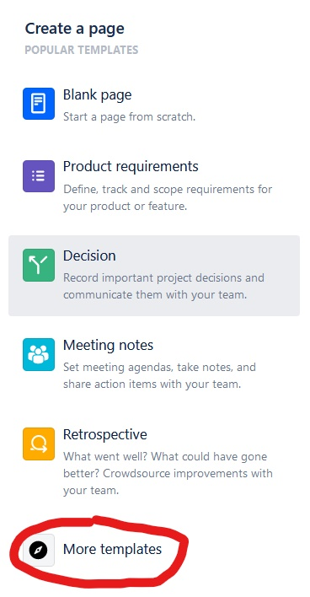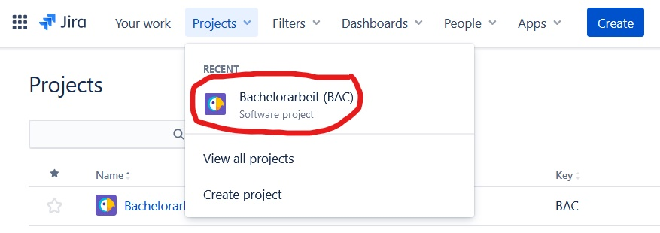On the left, click “Project pages”. Then, on the right, click “More templates”.

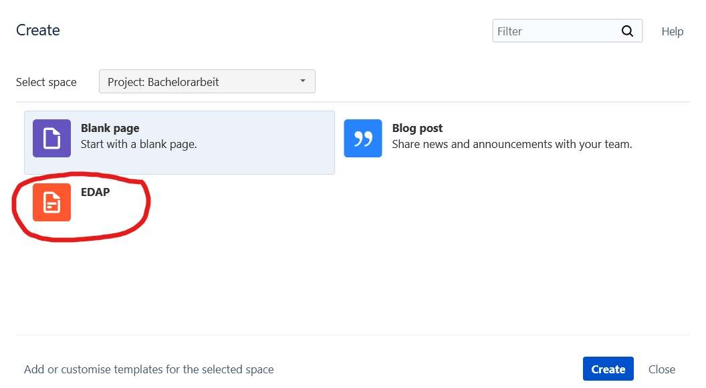A new page will open. Select “EDAP” and click “Create” on the bottom. You have now created a page using the EDAP template.

Keeping in mind the information from the checklist, fill out the template. You do not need to be very detailed, focus on documenting all important points in short sentences or bullet points.

If you want, you can save the page you have created by clicking “publish” on the top right. Make sure you have titled the page, otherwise publish is disabled.



**Step 4:**

Fill out the survey here:

<https://forms.gle/XZGwDFYYtM9gJtxY9>